Art desc

(ni lebih kepada susunan artwork based aku buat baru2 ni)

1. Drunk Artem

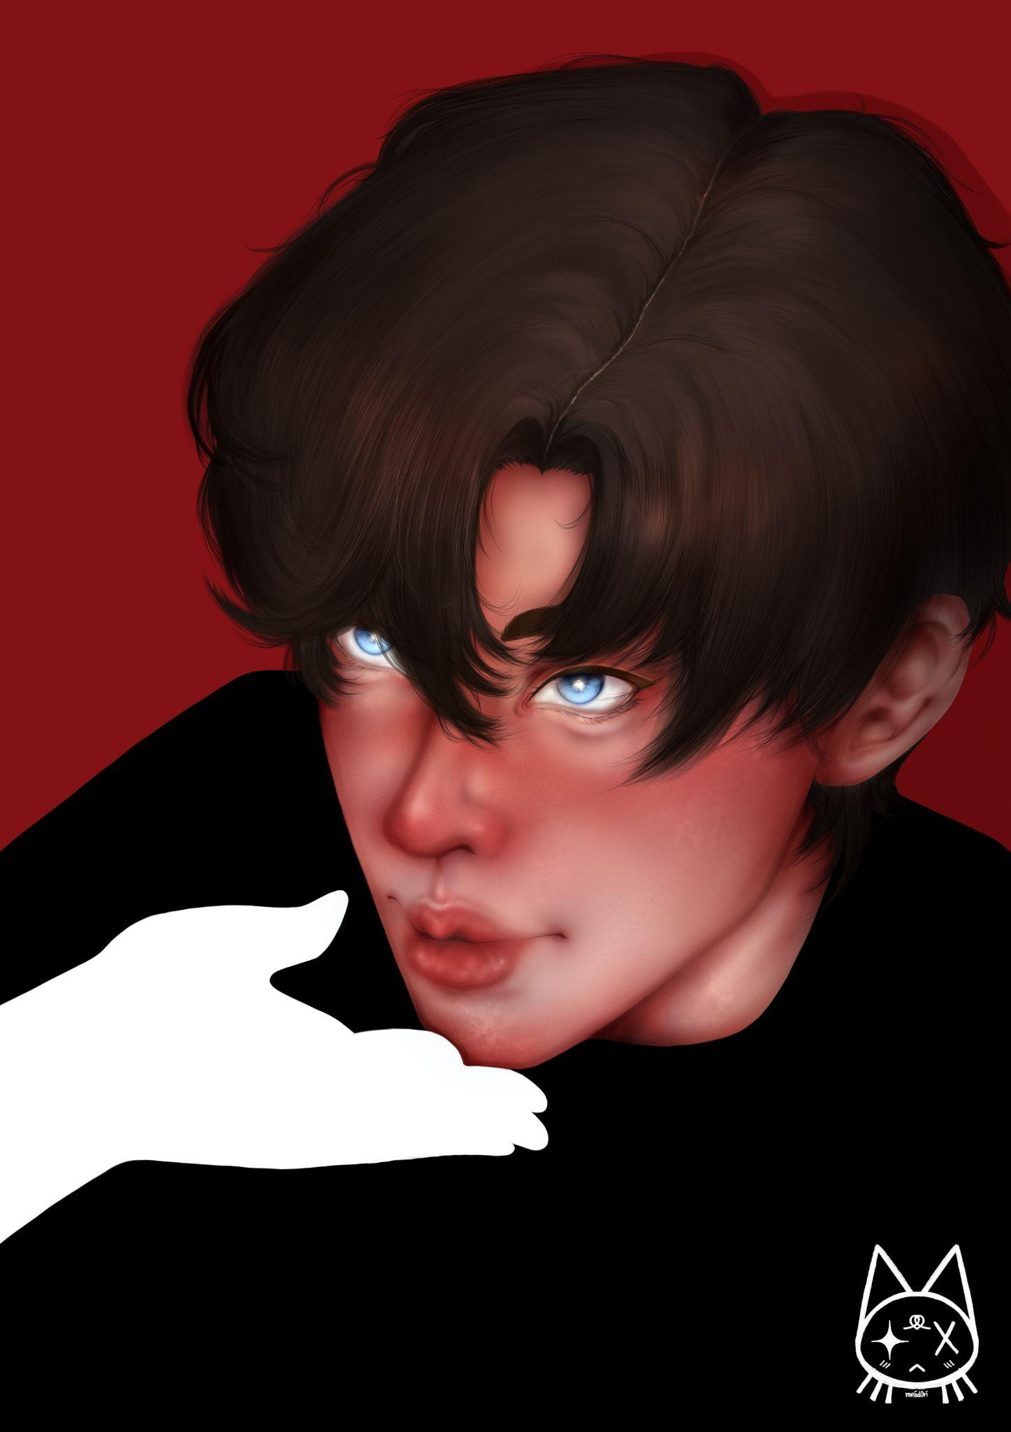

1. Artem - birthday series

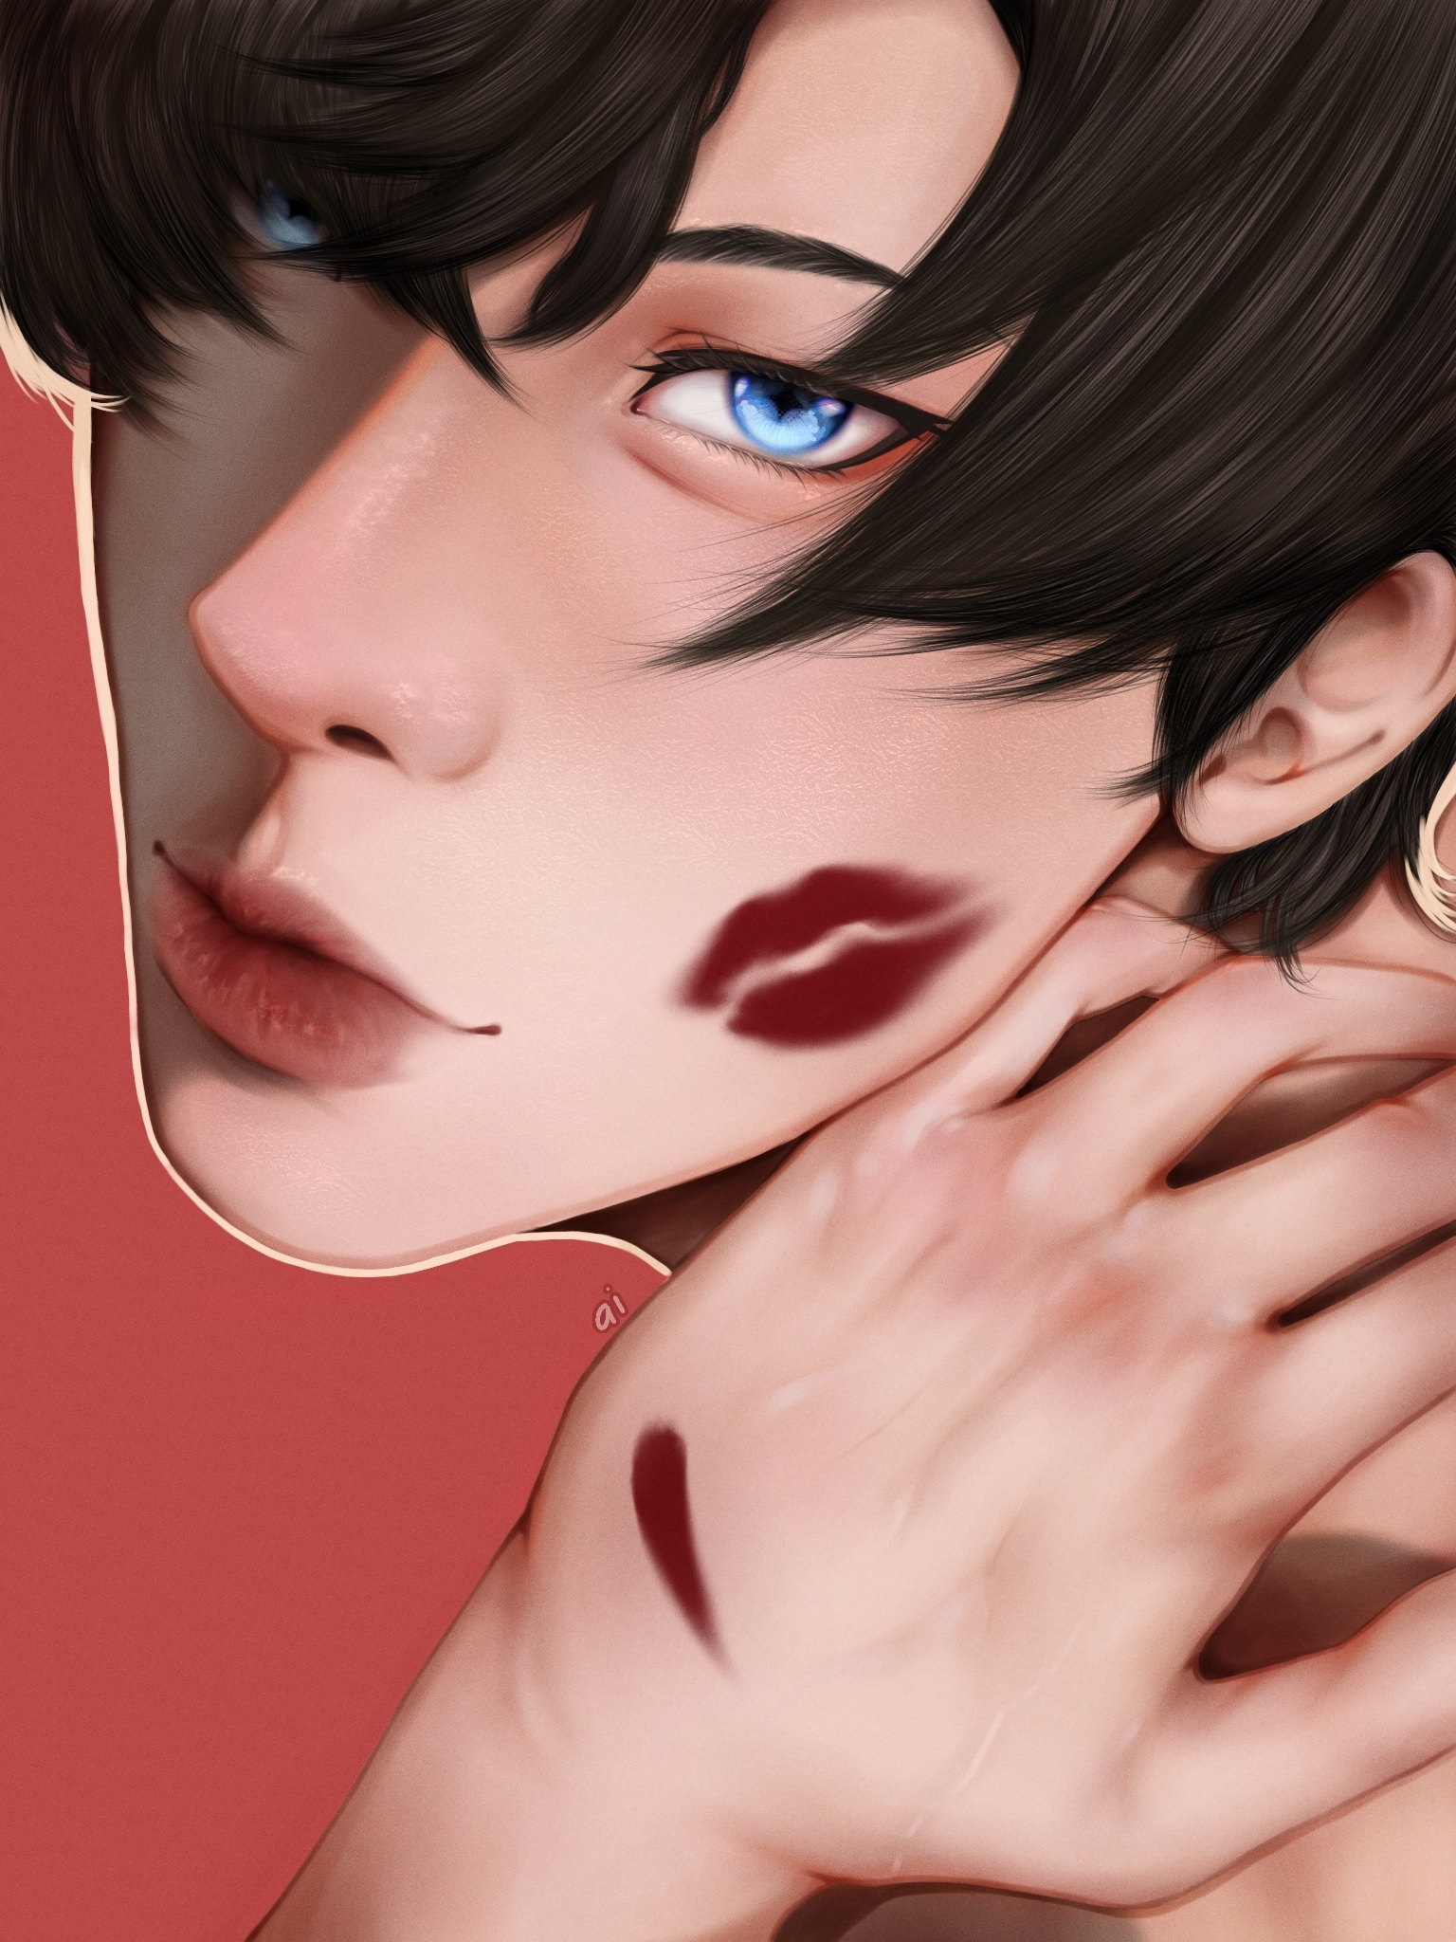

1. Marius - birthday series

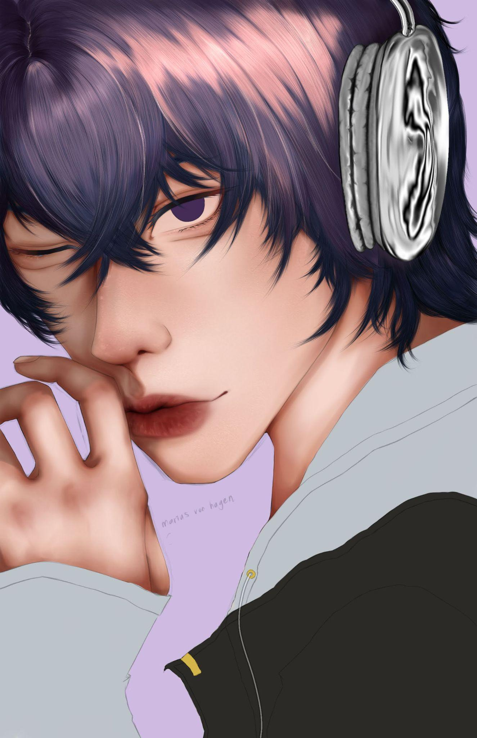

1. Zarith concept art

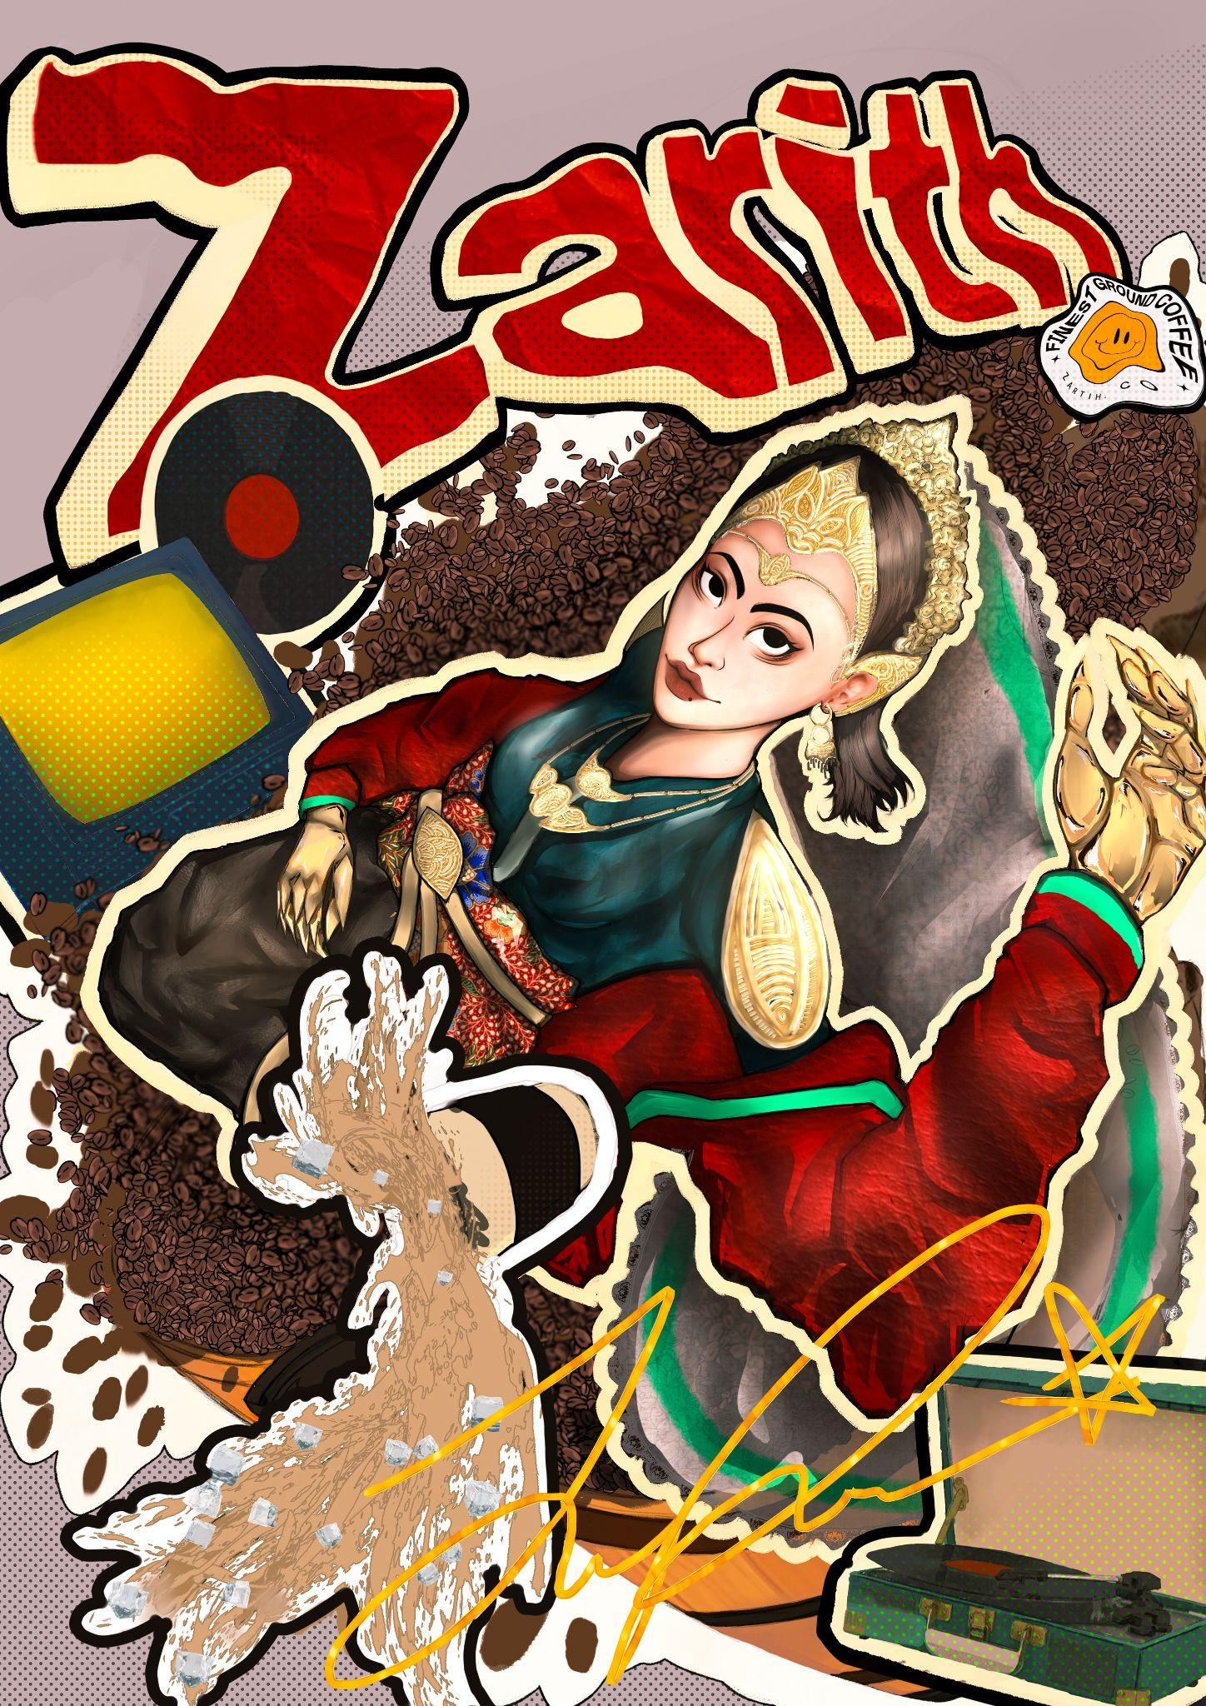

1. Zayne (Love and Deepspace)

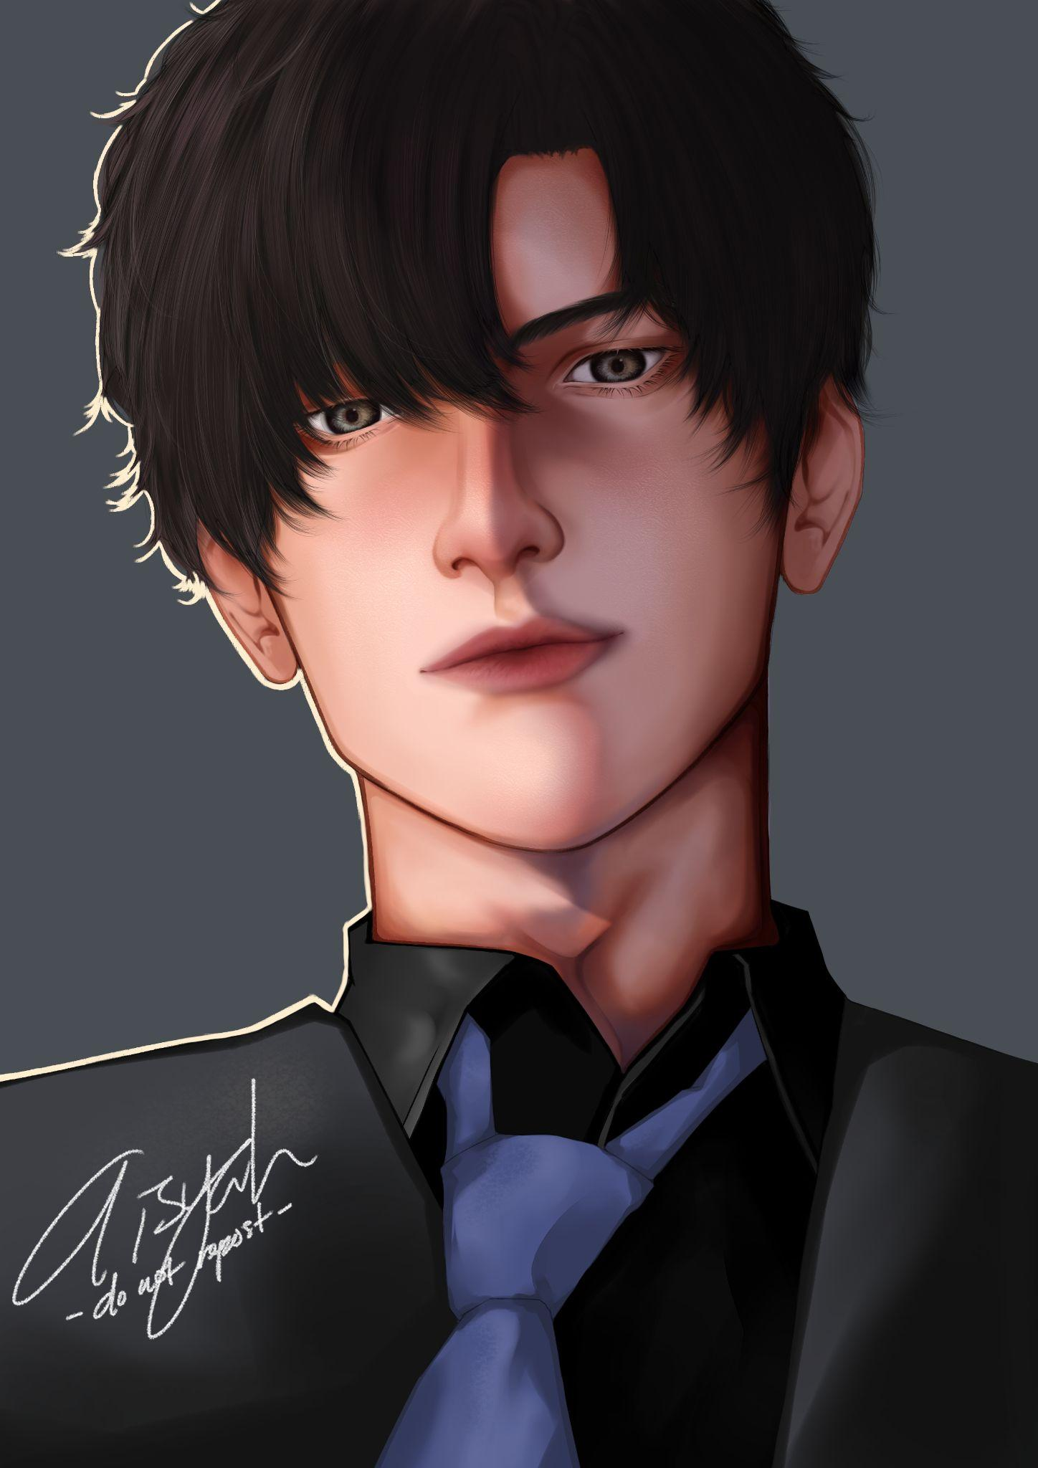

1. Hanilemen - commission series

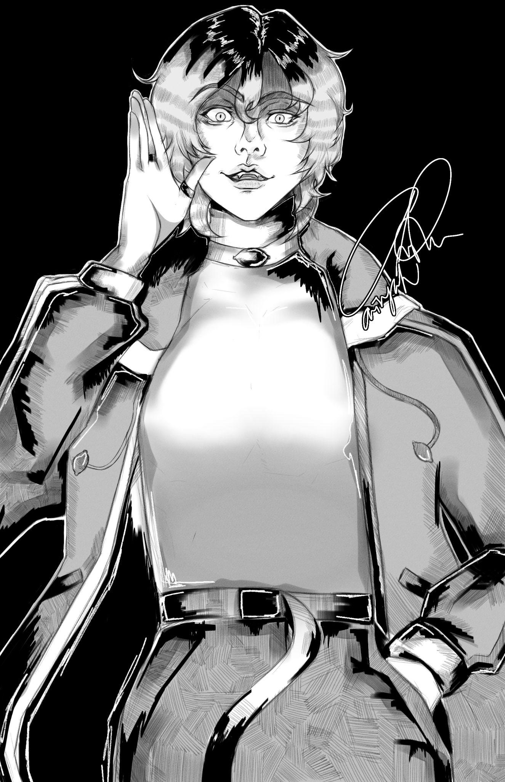

1. Childe (Genshin Impact) - commission series

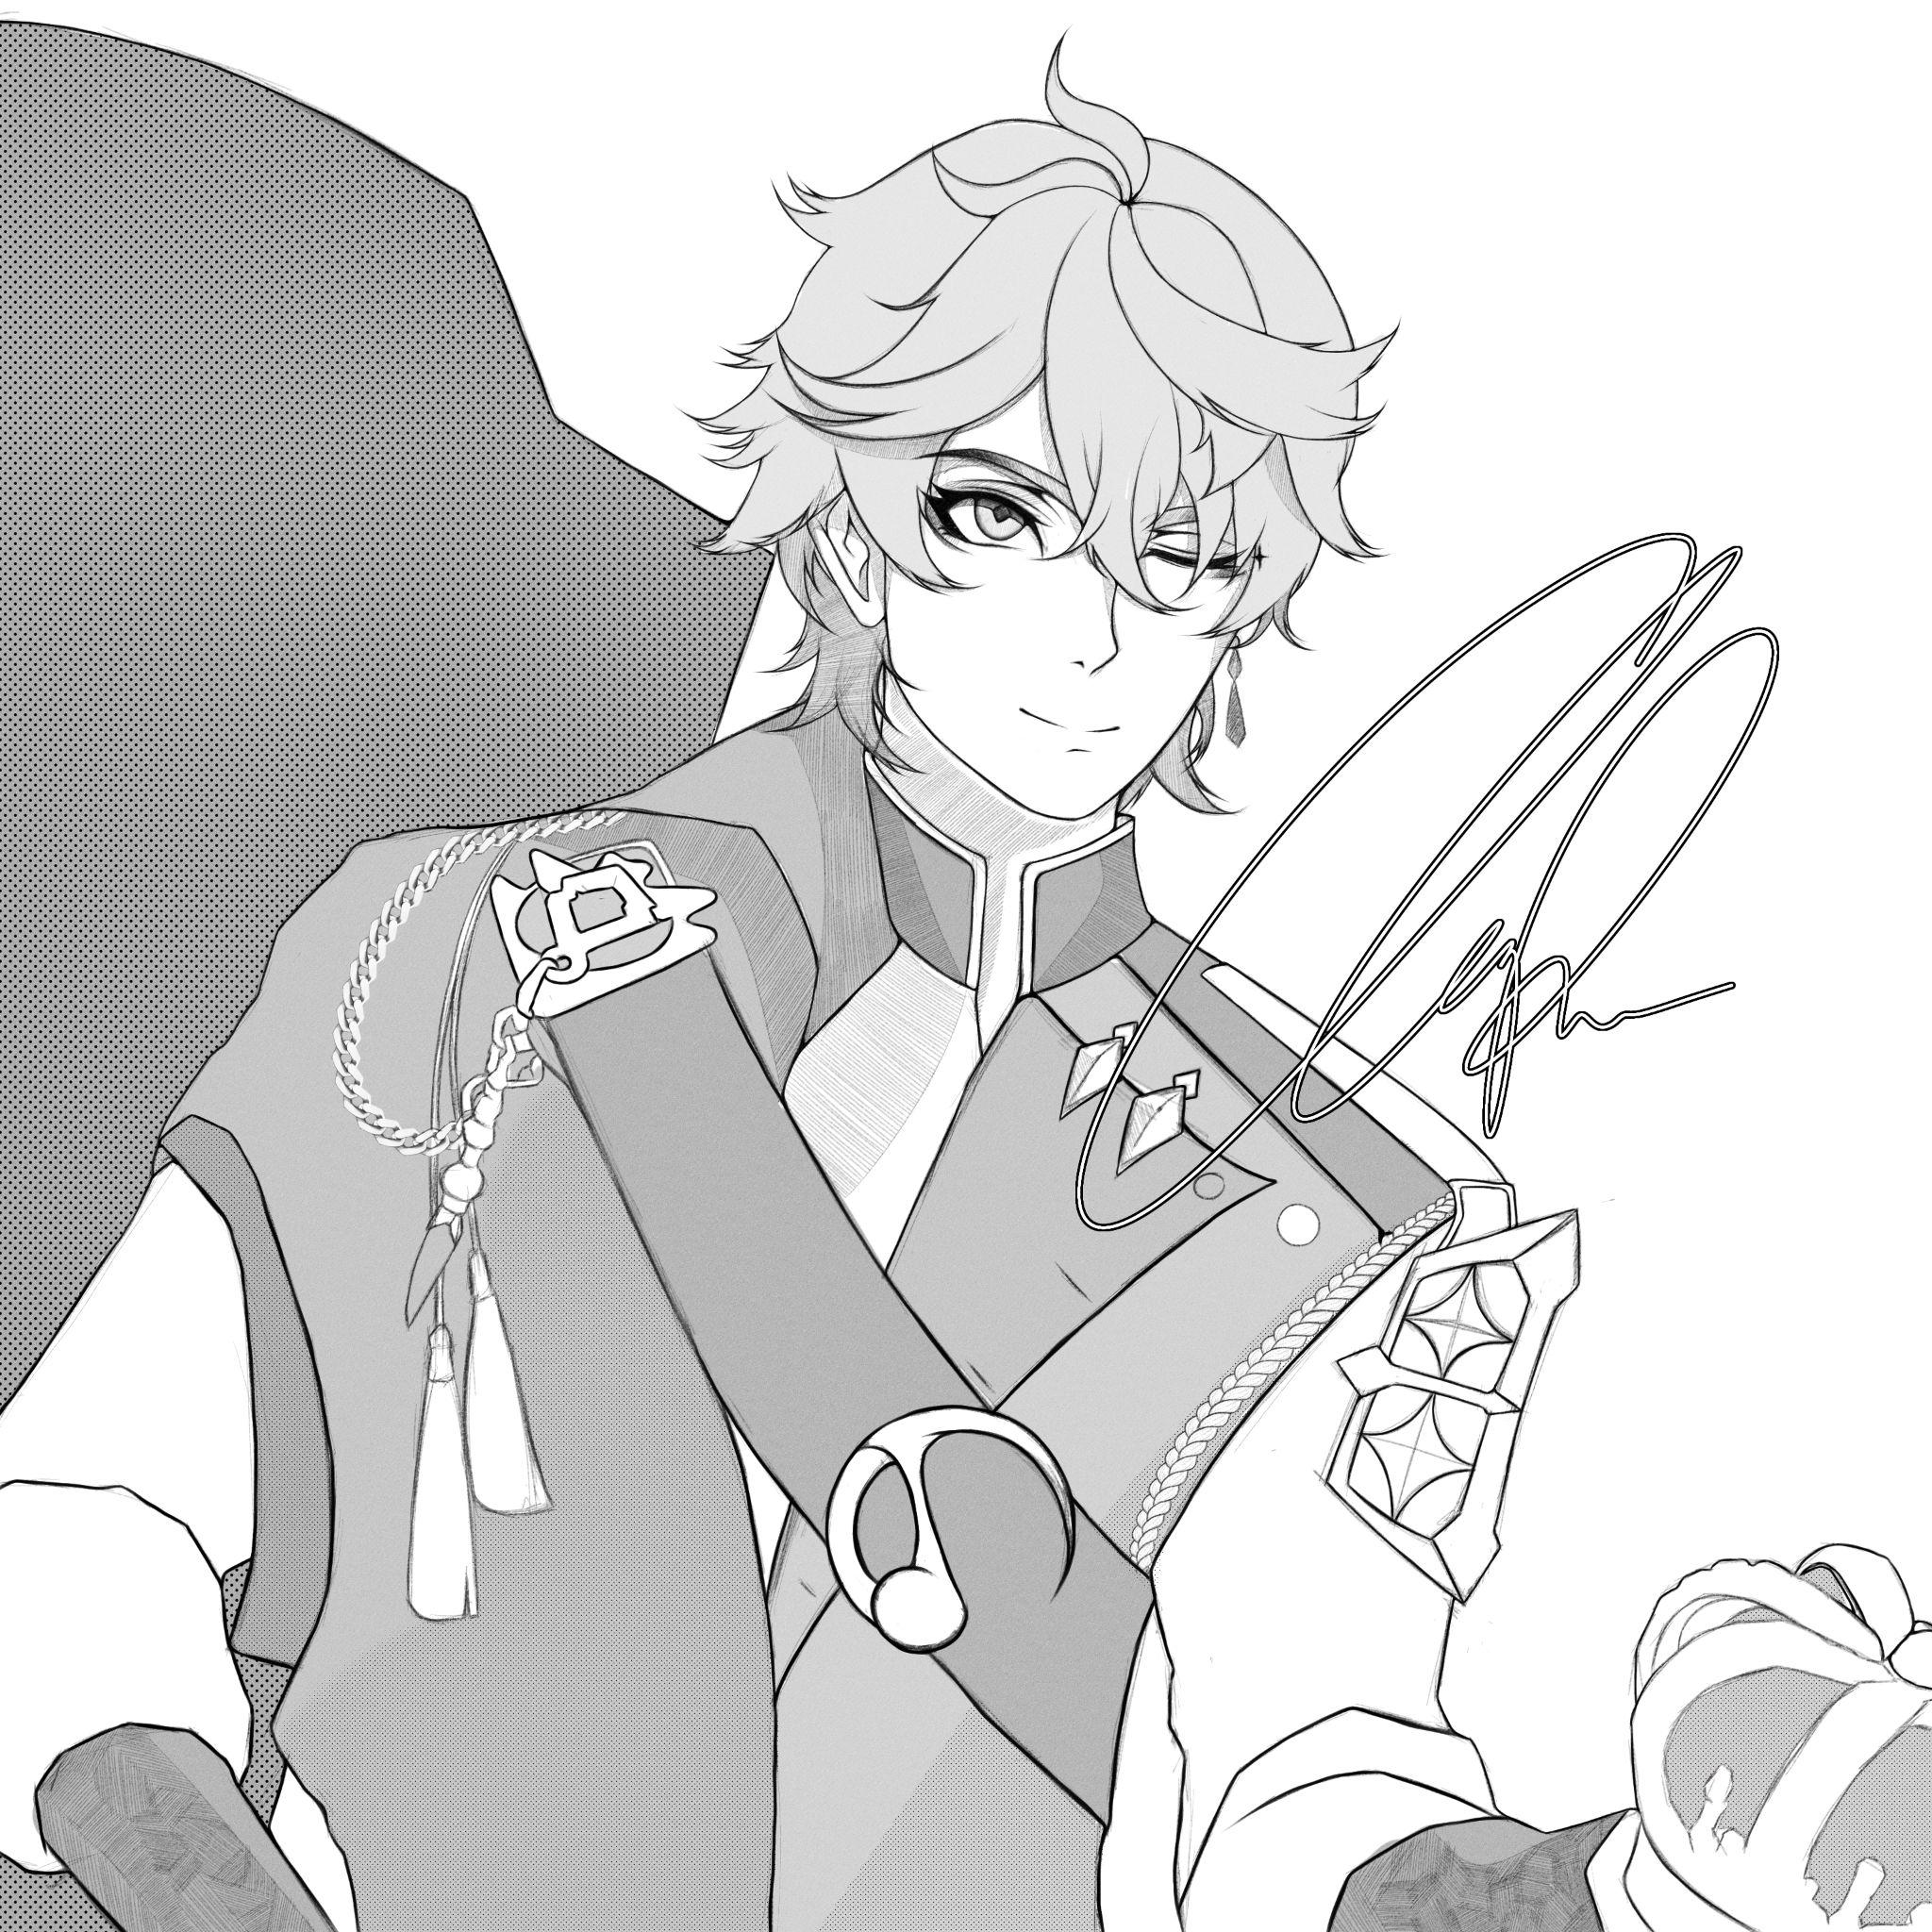

1. Eiser Leinz Grayan

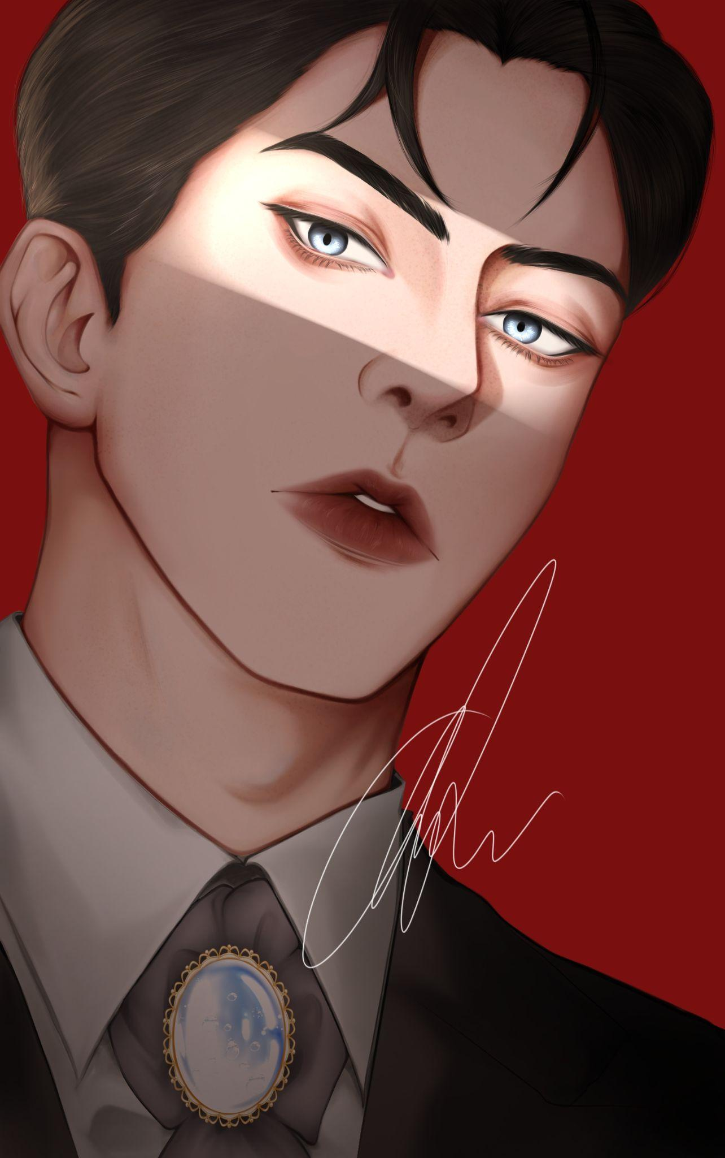

1. Axel (HOLOTEMPUS)

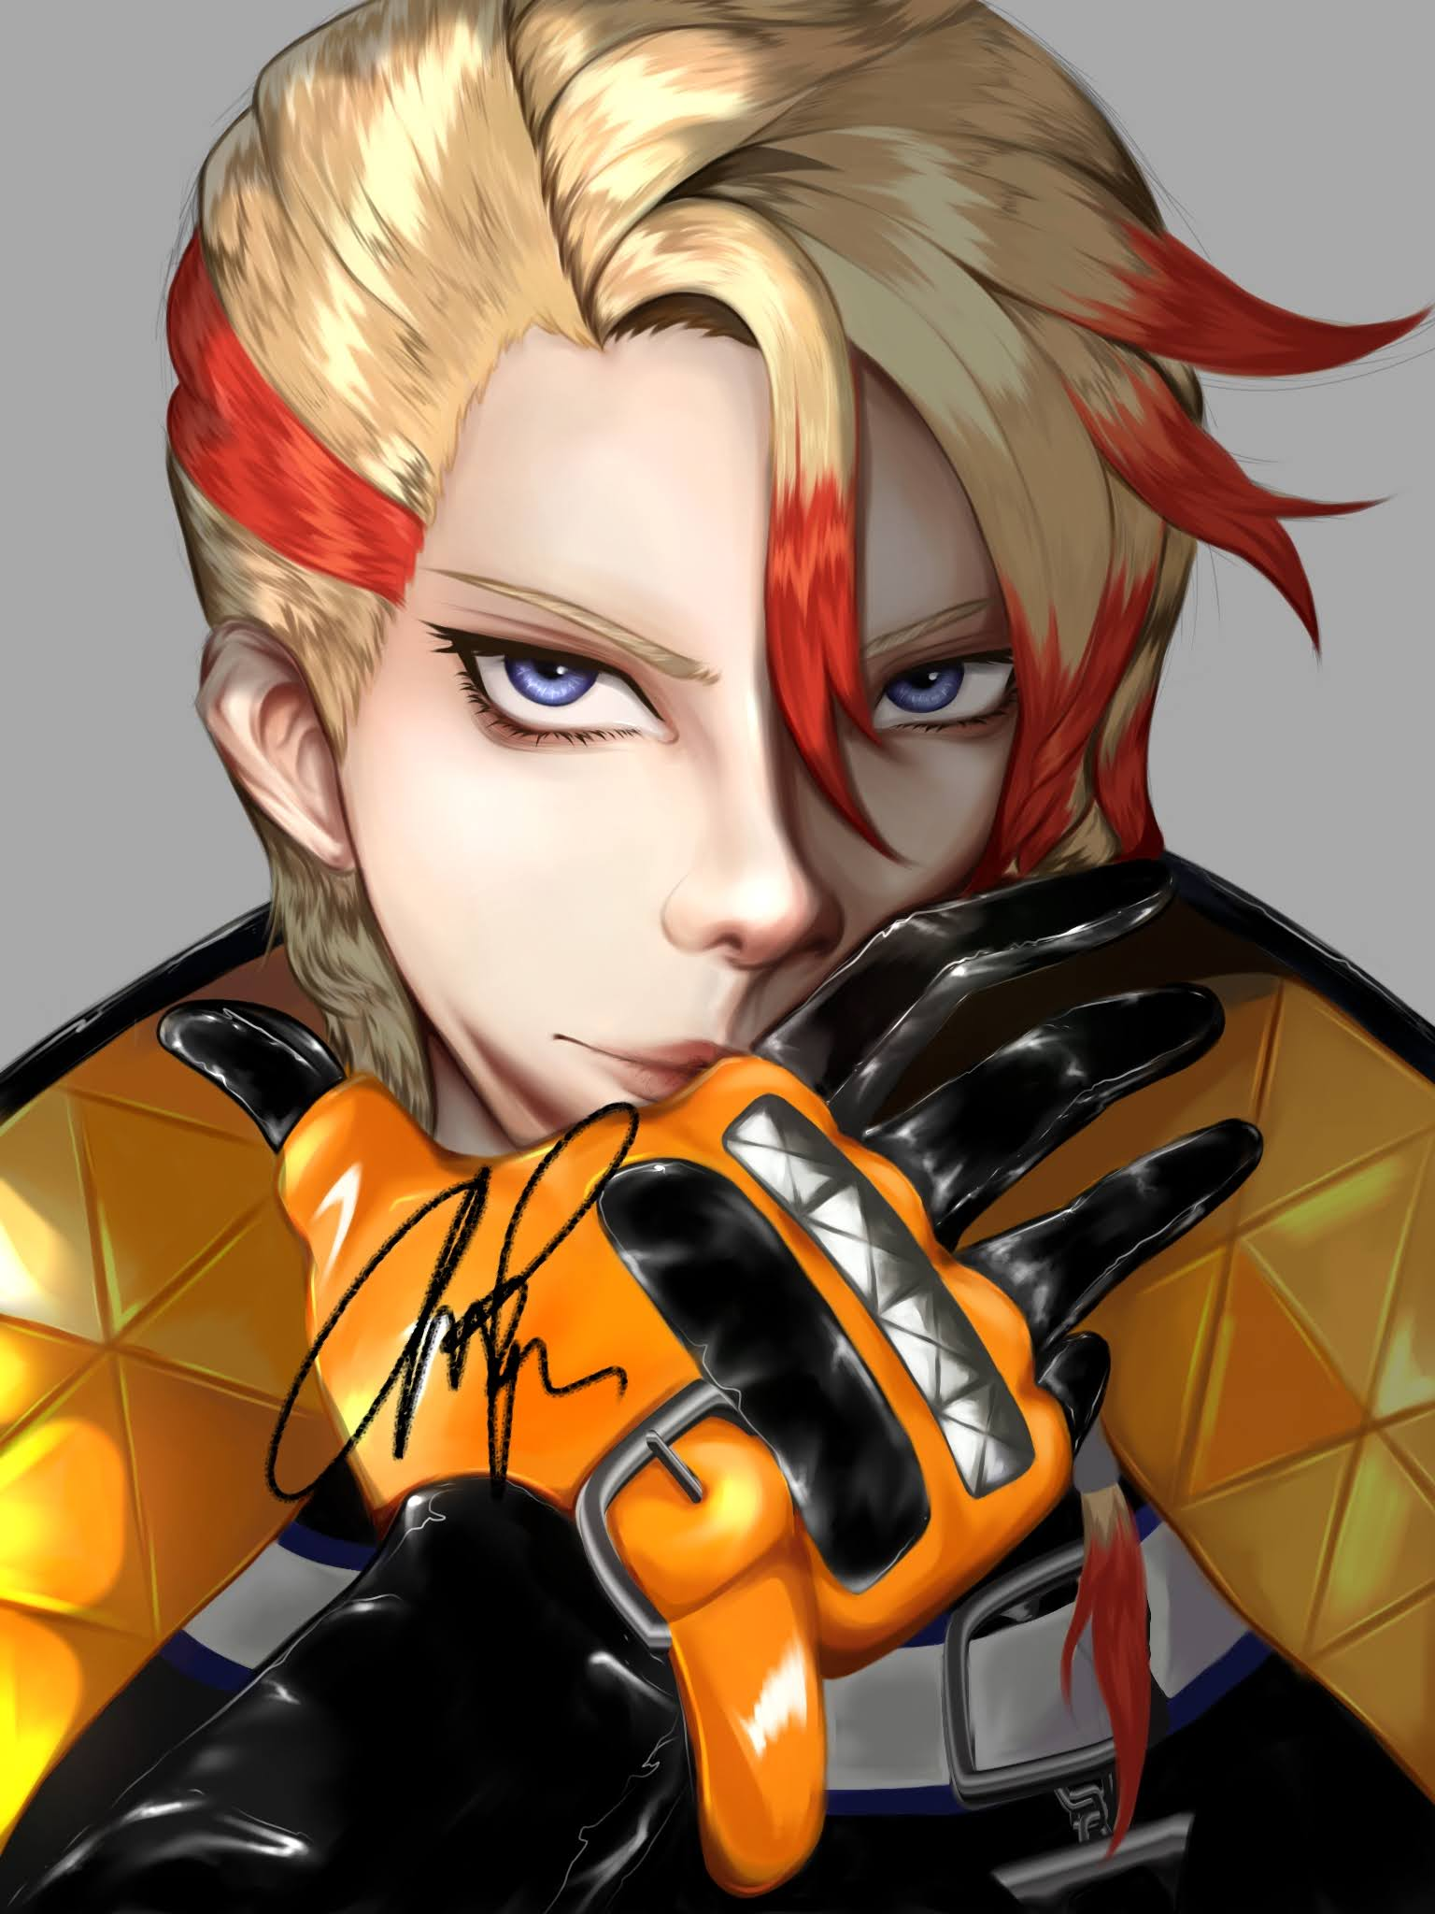

1. Zhongli (Genshin Impact)

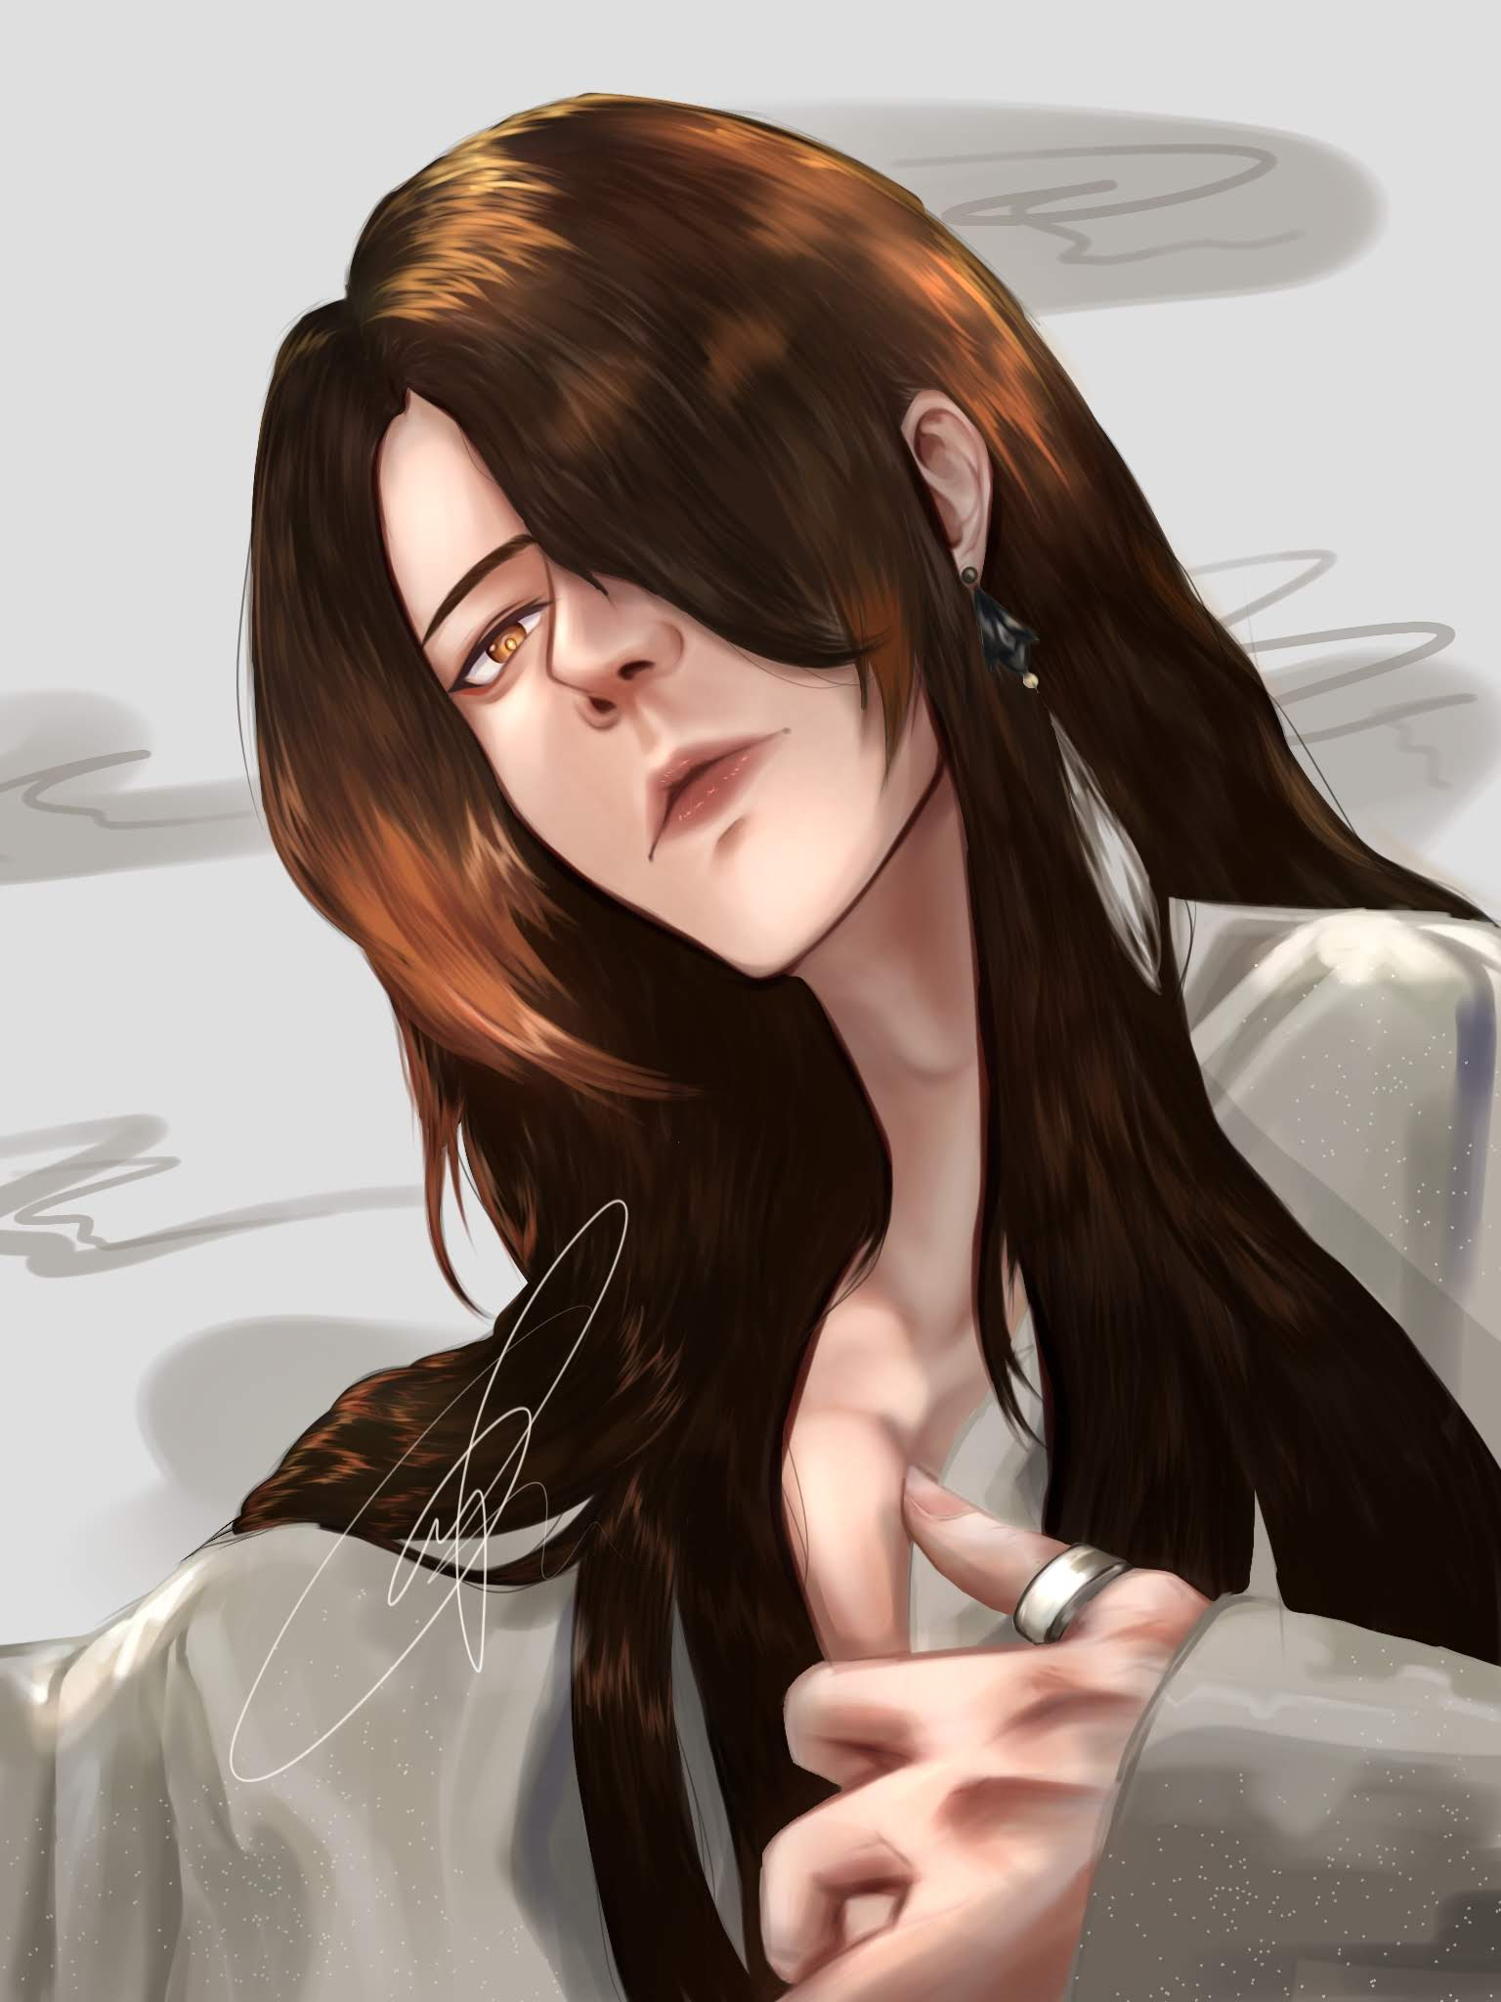

Quote:

* Bismillah headshot.

Bio

* 23-year-old self-taught artist, passionate about semi-realistic digital art, mostly of portraits. A self-proclaimed Zus coffee enjoyer and a fan. Once a month tak sah tak beli Zus coffee. Kadang-kadang beli lebih dari 2 dalam sebulan. A huge coffee addict.

Socmed handle

* Instagram: @mmiid0ri
* X: @2308ai
* TikTok: @mmiid0ri0

Email

* nrlaisyahsamsol@gmail.com